Revised 3/24/2021

Navarro County Volunteer

Firefighters Association

Active 911 User SOG

Active 911
We use an application called Active 911 as a supplement to radio pages. This is because poor radio reception can block receipt of pages. Active 911 also provides the data communicated from dispatch by voice as text so you can review it for information you may not have heard or remembered. It also provides several other features. Your department may modify this guide to conform to your department’s SOG and operations.

User Instructions
Please download Active 911. It is free, from your cell phone app store to your phone. You will be provided with a “device code” to enter in the application once it is installed. The Device Code will usually arrive in an email from contact@active911.com. This will allow you to receive pages/dispatches in the app.
Open the Active 911 app on your phone.
Click on Settings then type in your Device Code in the blank. Leave all other fields as they are.
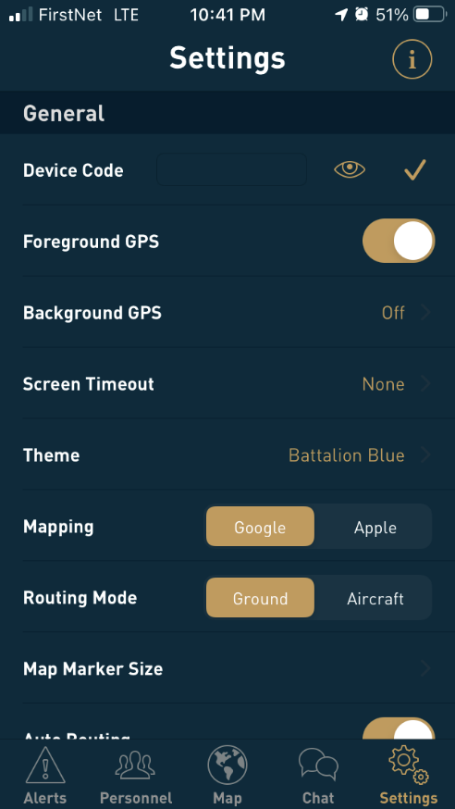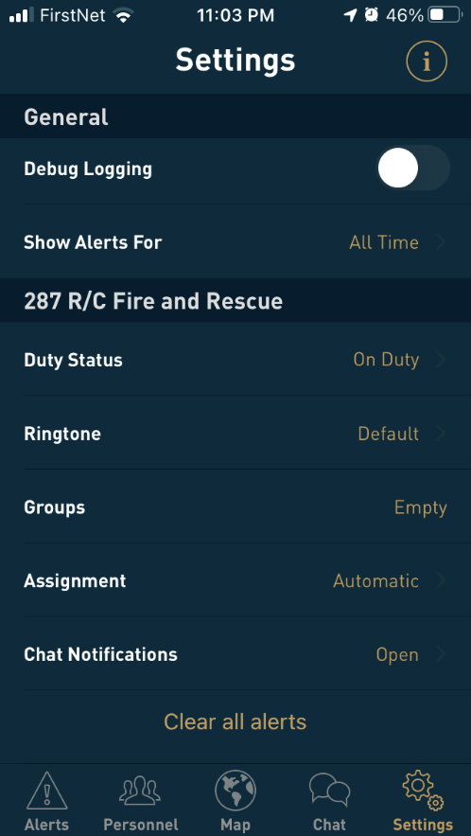
You can change the ringtone by scrolling down. This is the tone that you’ll hear when an alert comes in.
You can change your Duty Status from On Duty (receive alerts) to Off Duty (no alerts) if you’re going to be out of town or unavailable. If you change to Off Duty, be sure to change it back when you want to receive alerts.

Responding

How do I know when to respond?
You will hear a page on the radio and/or receive an alert from Active 911.

If you are not available to respond, access Active 911 on your phone.
- Click on Alerts at the bottom if they aren’t displayed.
- Click on the Alert (it should be the top alert in the list)
- Click on the Unvl (unavailable) button
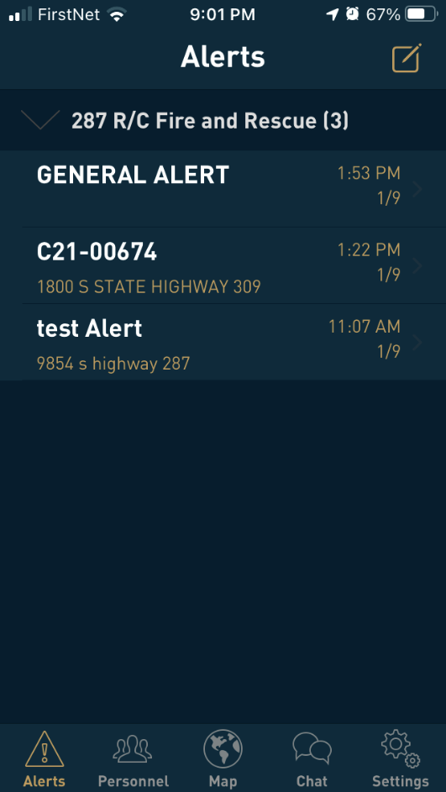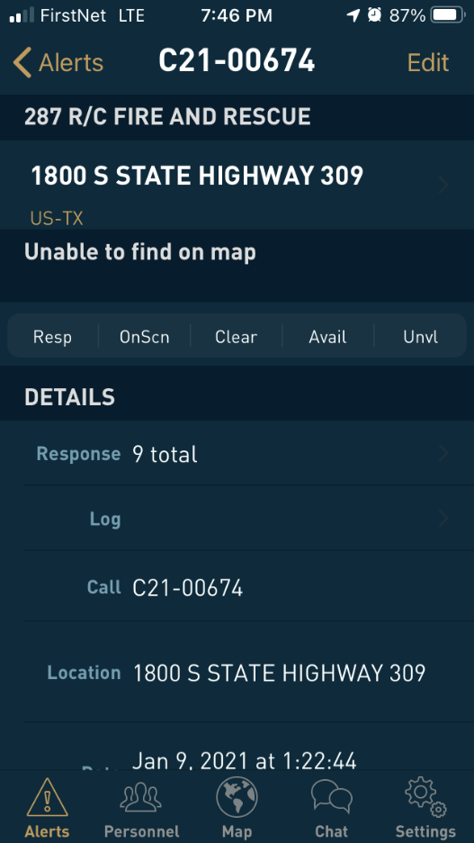

If you are available to respond,
- If you have a radio, respond on the radio as normal.
- Access Active 911 on your phone.
  - Click on Alerts at the bottom if they aren’t displayed.
  - Click on the Alert (it should be the top alert in the list)
  - Click on the Resp (responding) button if you are responding
  - If you do not want to immediately respond unless you are needed, click on the Avail (available) button
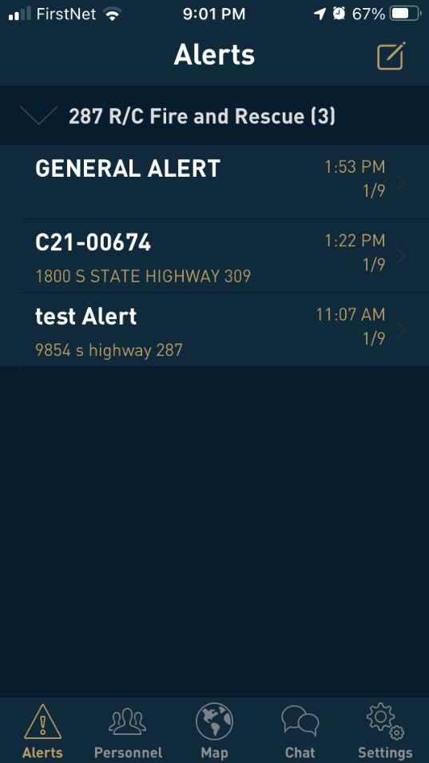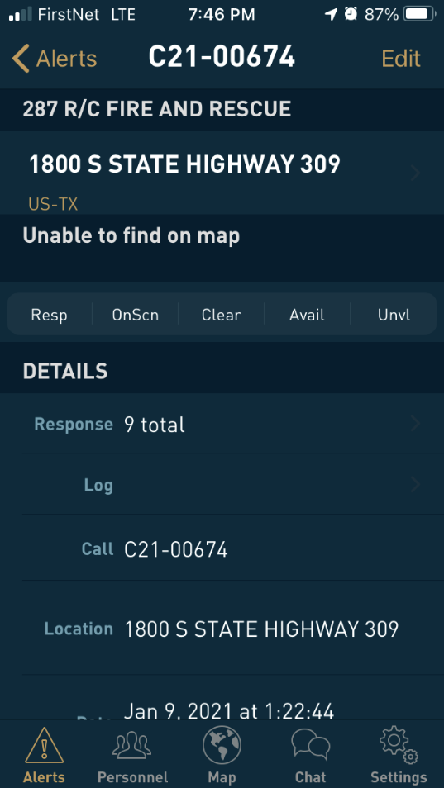
- Resp = Responding
- OnScn = You are On Scene
- Clear=Completed the call and returning to station or home
- Avail = Available to respond if needed, send Chat if needed
- Unavl = Unavailable for this call and not responding

- If you need to provide more info you can click on Chat, then on your department name, then on Everyone. Type your info in the box at the bottom and click on Send when finished.
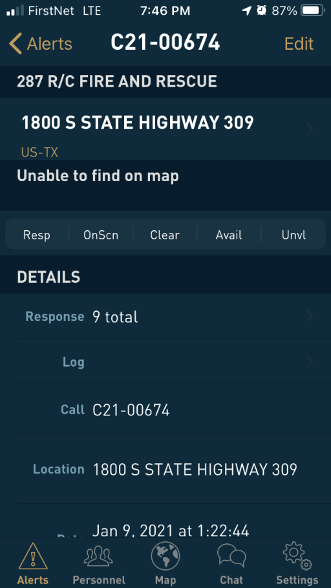
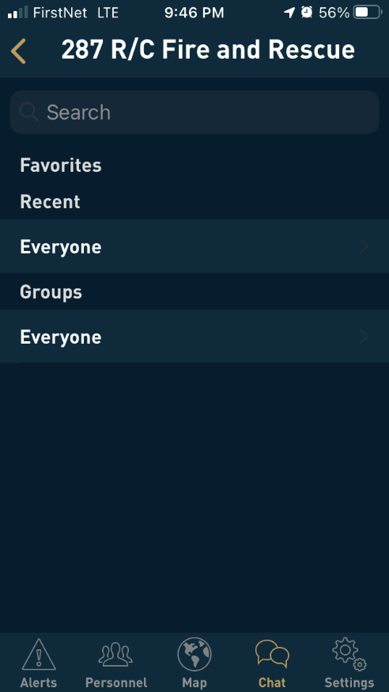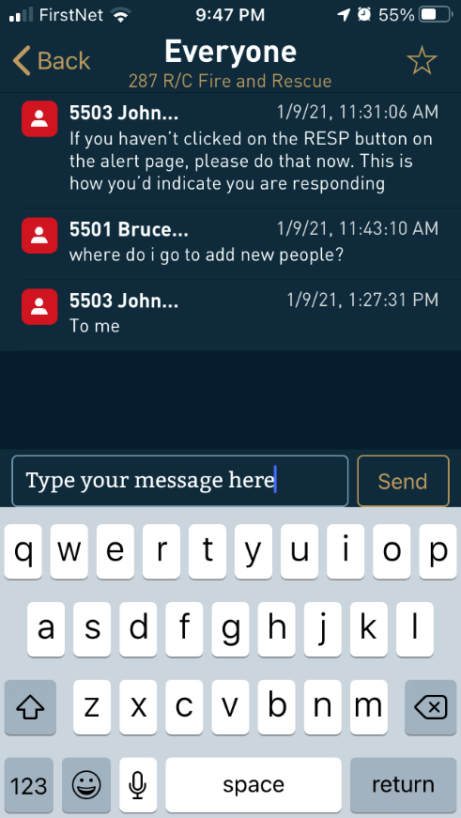

- If responding and you cannot notify us on the radio or Active 911, then follow your department’s process.
- Once on scene, update your status to OnScn in Active 911.
- If disregarding or on completion of the call, change your status in Active911 to Clear.
Generally, you will go to the station and meet up with other responders and the truck(s). Depending on the location of the incident, you may be instructed to meet the crew at the incident scene.

Active 911 Maps
On the Alert Page, if you see options for Google, Apple, and Active 911 under the address, you can click on the address and see a map with directions to the scene from your location. It will also show any other responders and their location.

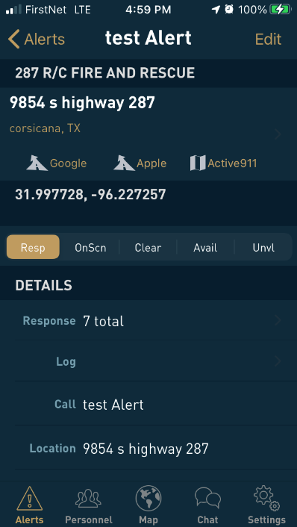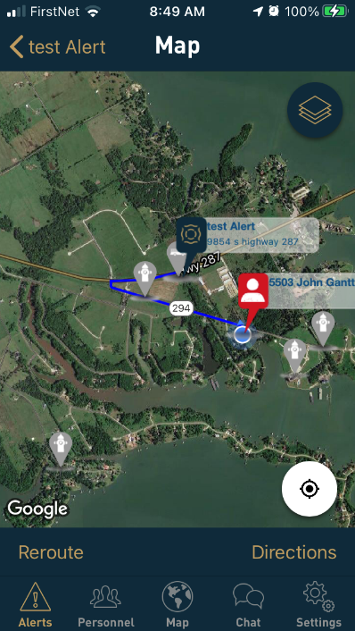
Note that the map is based on the GPS coordinates that dispatch enters. If there isn’t an exact street address, dispatch may pick the closest coordinates they have. Compare the map and route to what is actually in the dispatch address as the route or location may be inaccurate on the map.
The map will normally show other department units that are responding and their approximate location. Fire hydrants that have been added to the map may also appear.

If “Unable to find on map” is displayed under the address you can scroll to the bottom and click on Maps app. This may display the location of the call and your driving route to the scene. Touch GO to start navigation
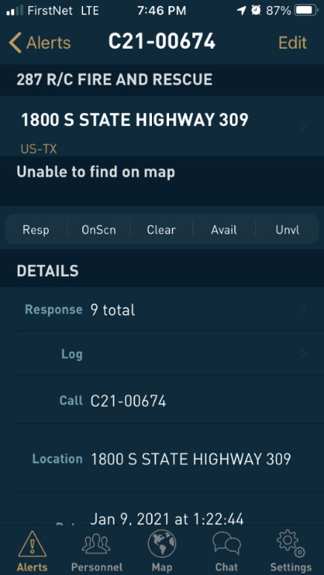
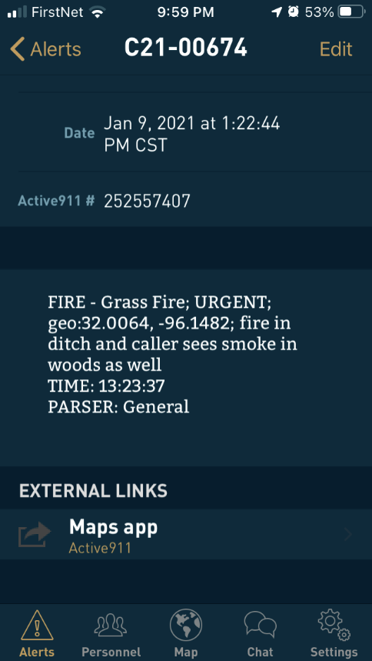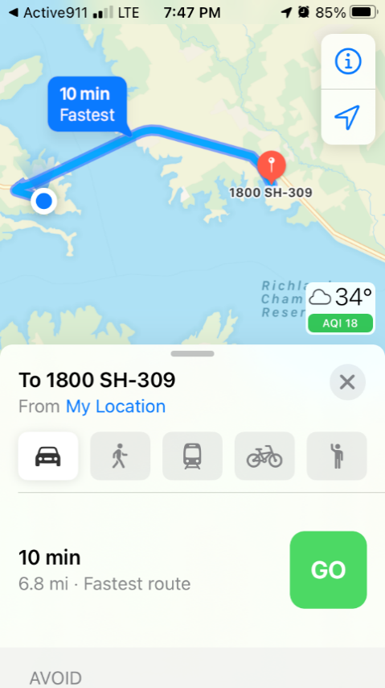

Mapping Issues
Sometimes Active 911 maps the location wrong. This is especially true if there is not an exact address. This may be because the address exists in more than one local city or has a mailing address for a city but is really out in the county. It can also occur when dispatch puts in a GPS coordinate (they pick from a map I believe) and the GPS is incorrect. It is important to review the displayed location and compare it to what you know of the area and what the message in the dispatch/radio broadcast says. For example, I’ve seen a dispatch to Hwy 309 near US 287 that mapped to close to Kerens due to uncertain GPS coordinates. When I heard 309 near 287 I knew that the mapping was off when I looked at it in Active 911. As with all dispatches, we need to use some common sense. I have found that most of the time, the mapping is correct.

There are 2 ways to get mapping in Active 911. Generally, the easiest is to click on the address in the dispatch. This displays the map, directions, and units responding. If this doesn’t look right, you can go to the bottom of the screen and click on Maps app. This uses a different mapping process. It does show the route but doesn’t show other units responding.

General Alerts
During the first week or two of getting alerts on Active 911 you may sometimes get a GENEAL ALERT. This is created when dispatch closes the call and sends the summary email to your department email account. The General Alerts should stop within a week or two and they will just get added as an update to the original call.

Help
Additional help and documentation: You can find additional help and documentation online at:
https://active911.atlassian.net/wiki/spaces/AED/pages/29819026/How-to%2Barticles

