Revised 4/24/2021

Navarro County Volunteer

Firefighters Association

Active 911 Administrator SOG

Tracking
Update 4/24/21 – section on Navarro County Command agency added.

Active 911
We use an application called Active 911 as a supplement to radio pages. This is because poor radio reception can block receipt of pages. Active 911 also provides the data communicated from dispatch by voice as text so you can review it for information you may not have heard or remembered. It also provides several other features. You may edit this SOG to customize it for your department. We suggest you delete the Administration sections to create a User SOG or job aid.

Administration
As Chief of the department you are set up as an administrator for your account. John Gantt is also an administrator. Please do not change the permissions or delete John Gantt from the account or the association will not be able to pay for your subscriptions. The association will not make any changes to how you set up your department without your permission.

Getting Started
You should have received the email below.
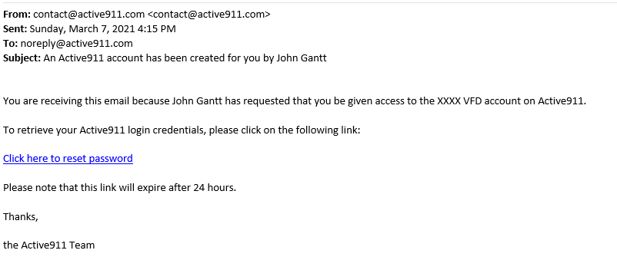
In the email, click on the link Click here to reset password. This will take you to Active 911 where you will need to create a password. You MUST create the password within 24 hours of receiving the email or a new email will need to be sent to you. If this happens, contact John Gantt.
Passwords must meet the following requirements:
- 6 characters or more
- At least one uppercase
- At least one lowercase
- At least one number

Department Summary
You are now ready to enter your members. Access Active 911 at https://active911.com. Click on the Account Login button.
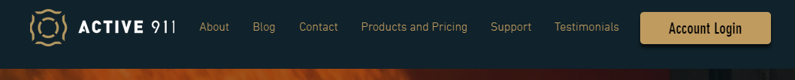
Login using your email address and the password you created when you registered .
You should see the screen below:
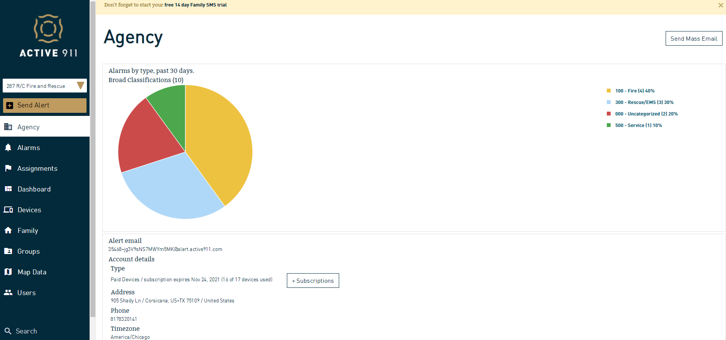
This screen shows a summary of the calls that have come through Active 911 for your department as well as basic account info.
On this screen you can see how many devices (subscriptions) are assigned to your department and how many of them are in use. If you have more than 2 extra subscriptions, please let John Gantt know so that they can be moved to other departments who need more subscriptions. If you need more subscriptions for new members, let John Gantt know and they will be added. See Adding and Deleting Members section for more details.
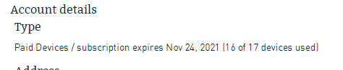
You can scroll down this page to see the Options section.
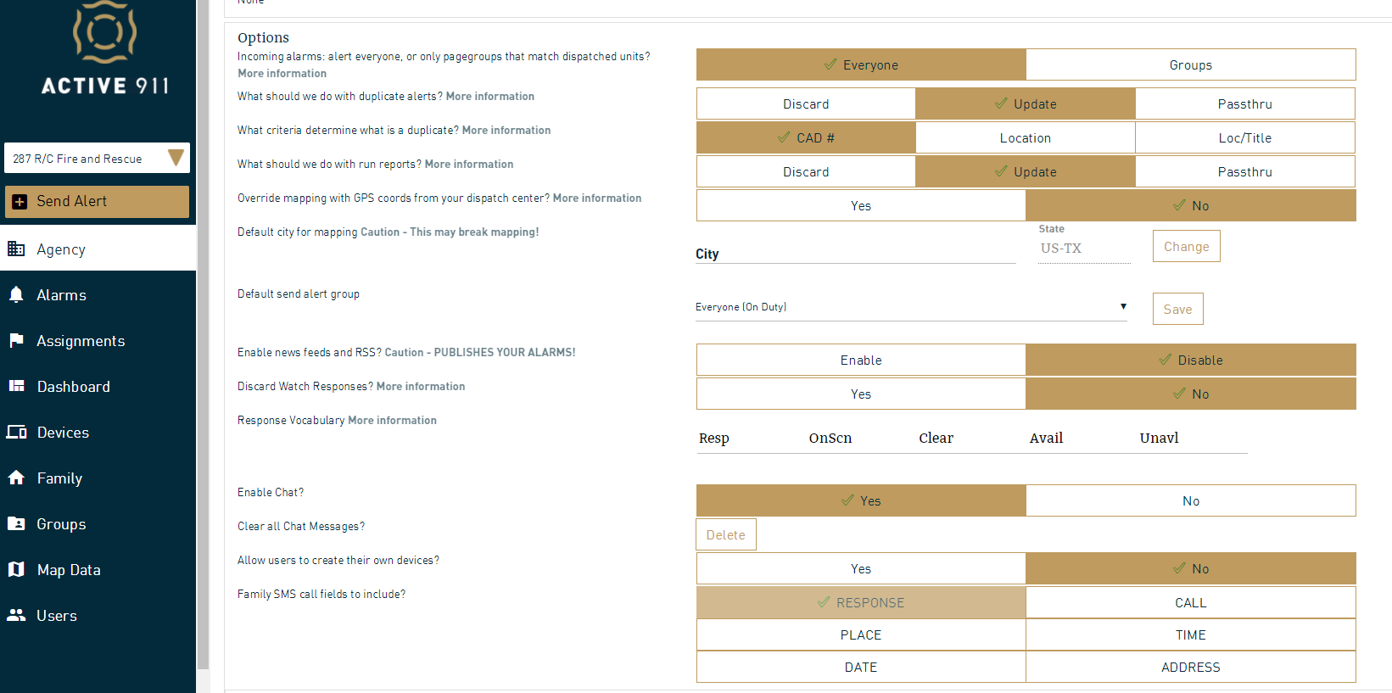
It is strongly suggested that you not change any of these options without contacting John Gantt as it may impact your ability to receive and respond to pages. It will also be in conflict with the User Instruction later in this document.

Adding Members
Pick Devices on the left menu. You should see a screen similar to the one below including your device and John Gantt.
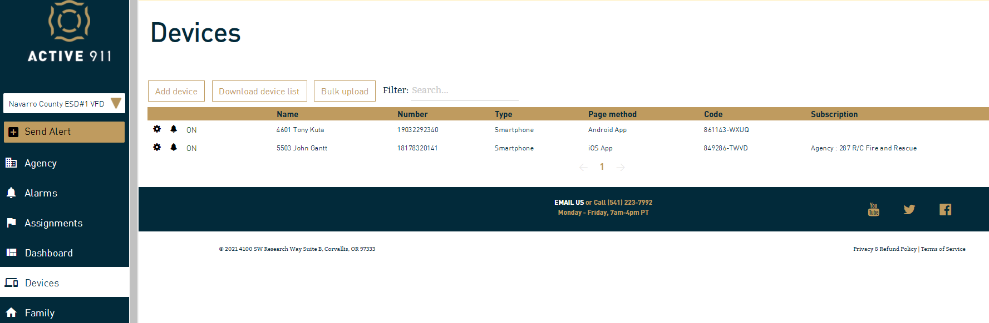
Note that your name includes your unit number, for example 4601 Kuta, Tony
To add a member, click the Add Device button. This will bring up the following screen:
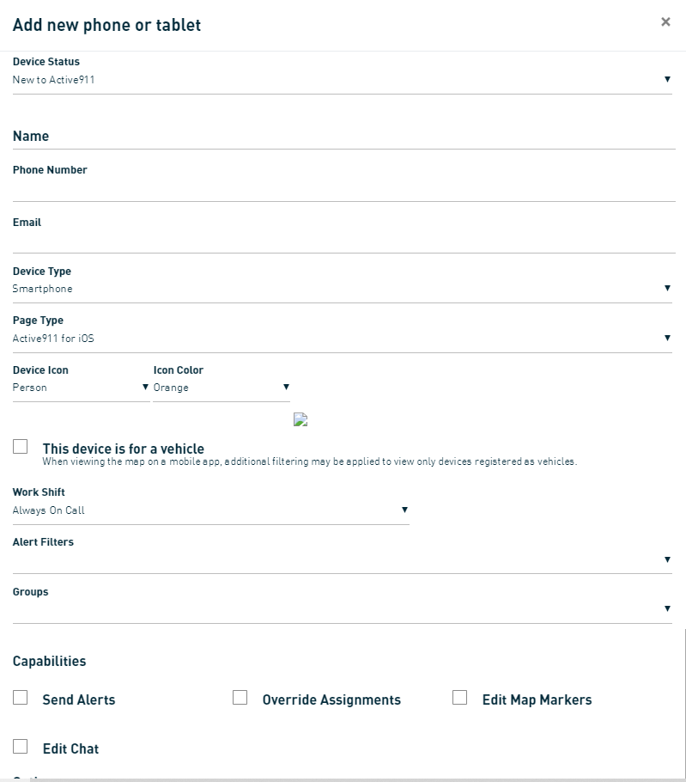
Fill in the fields for the member
Device Status: New to Active911 (this is the normal entry)
Name: Enter names beginning with the person’s unit number. For example 5503 John Gantt. If the member does not have a unit number, assign a unit number at the end of your group. For example, if your unit numbers begin with 65XX, assign unit 6549. The next member without a unit number would be 6548 and so on counting backwards from XX49. Using this format allow the persons unit number to appear on maps and other reports.
Email: enter the user’s full email address. This is how they will be contacted to give them their Device Number. They need the Device Number to put in their phone. See User Instructions section for more user details.
Device Type: Pick the type of device the user has. Usually this will be Smartphone. The options are:
- Smartphone-Select for iPhone, Android phones, Blackberry, and Windows phones.
- Cell-All non-smart phones
- Tablet-Select this for iPads, Android Tablets, and Windows Tablets.
- Landline-Select this for members that want to receive a phone call for alerts
- PC-Select this for Windows PC, Webview, and Email devices.

Page Type: Available options will change based on the Device Type you selected above. Not all of the options below will be available for all types of devices. For smartphones, pick if the user’s phone is Android, IOS (iPhone/Apple), or Windows.
For non-smartphones pick SMS and pages will arrive by text.
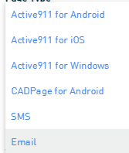
- Active911 for Android-Select this for Android devices using the Active911 app.
- Active911 for iOS-Select this for iPhone or iPad using the Active911 app.
- Active911 for Windows-Select this for Windows Phones and Windows Tablets using the Active911 app
- CADPage for Android-Select this for Android devices using the CADPage app. This is not generally used.
- SMS-Select this for any device that wants to receive alerts via text message.
- Voice Call-Select this to get a voice call to a phone.
- Webview-Select this for a PC using Webview.
- Email-Select this to receive alerts via emails.

Device Icon: the default is Person and this should normally be your entry. If you have vehicles equipped with cellular tablets, contact John Gantt to discuss this option.
Icon Color: The color standard established for the county is orange for firefighter/EMS members that are not officers and red for members that are officers. We have also established grey for hydrants and yellow for fire stations. Please use these standard colors. If you want to use other colors for other types of members, please coordinate with John Gantt.
Work Shift: We suggest that you leave this as Always on Call. The use can adjust their status individually if they don’t want to receive pages at various times.
Alert Filters: Leave blank
Groups: Leave blank
Capabilities: Most members will not have any checks in this area. You should decide who in your department besides yourself will be able to use the additional capabilities. If you want a person to have a capability, check the appropriate box. Those capabilities are:
- Send Alerts-Select this to allow the device to use the "Create Alert" option within the app on the device to send alerts through the account. This allows the person to create a non-emergency alert or page to all of your department for things like reminders of meetings, training, etc. This alert does not go through dispatch or the radio. You may want to restrict this to the chief and assistant chief or officers.
- Override Assignments-Select this to allow the device to override other device's assignments within the personnel screen of the app on the device. This is used for advanced setup. If you are interested in setting up advanced features, read through the online documentation to understand the options and impacts to your department. Generally, leave this box unchecked.
- Edit Map Markers-Select this to allow the device to add map data points directly from the map screen within the app. Use care here as a user with this feature can not only add markers to the map but delete them as well. We are asking all departments to add markers for hydrants or other water sources to the map so they are visible when responding and looking for the nearest water source. See Hydrant Mapping Project section of this document for details.
- Edit Chat-Select this to allow the device/user to delete chat messages within the app sent by any device. Without this permission selected, a device/use can only delete the chat messages they sent. Generally leave this blank except for designated officers in your department.
Don't re-page updates(Only applies if using Groups)-Leave this blank.
Once you have completed all the fields, click on ADD button at the bottom right. This will pull up a new window asking if you want to create a user. Fill in the person’s first and last name (unit number not required) and click Create User and Send Welcome Email. This will send an email to the user with their Device Code that they need to input to activate their device (smartphone).
There is an option for bulk adds but we do not recommend this as it does not send the welcome emails to the users and you would have to give each user their Device Code manually.

Officers
Once you have all your officers devices created and welcome emails sent, you may want to grant someone, like your assistant chief, additional permissions. You can do this by selecting USERS on the left menu area.
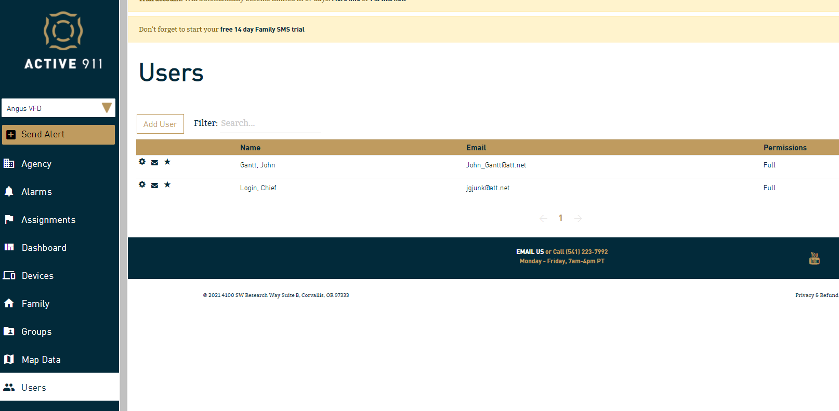
Click on the spoked wheel on the user you want to add permissions/capabilities to.

Checking Member Activation
Looking under Devices on the menu, until a member activates the app on their phone, they will show up with a pink highlight across their member info. Once they activate the app the highlight will disappear and you will know they are receiving alerts/pages.
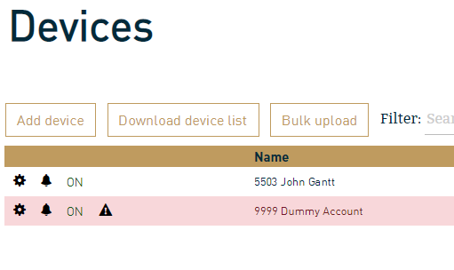

Changing Members Unit Number
If a member’s unit number changes, go to the Devices tab and click on the spoked wheel icon by their name. Edit the name to change the unit number and save the change.

Download Device List
Once you have all your members entered, you can download the complete list of devices for your department. This may be useful as a way to manually provide the Device Code if a member misses the email or isn’t able to get an email with their Device Code. Click on the Download device list button.
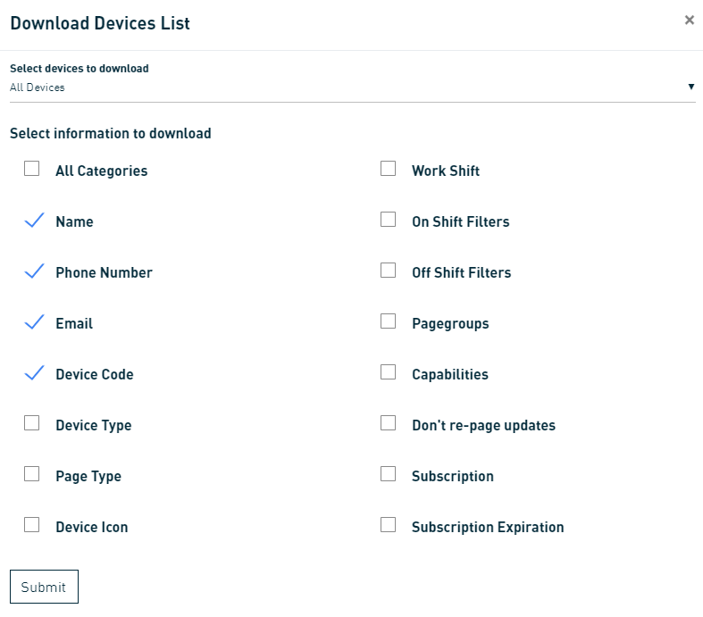
Select the info you want to download by checking the boxes and click on Submit. This will create a file in CSV format that you can download and open in a spreadsheet.

Deleting Members
When someone leaves your department you are responsible for deleting their device from your department. Login to Active 911 and click on Devices. Click on the spoked wheel on the line with the member who has left.
Scroll to the bottom and click on the Delete button. Confirm delete. This will remove the member and free up a subscription under your department.

Updates
During the first week or two of getting alerts on Active 911 you will sometimes get a GENEAL ALERT. This is created when dispatch closes the call and sends the summary email to your email account. Shortly after you are set up on Active 911 you will receive an email from them advising that they have configured a “parser” on your account. This is a confirmation that they are receiving dispatches for your department and no action is needed on your part unless you see problems with the data you receive. Once parser is added to your account the General Alerts should stop as they just get added as an update to the original call.
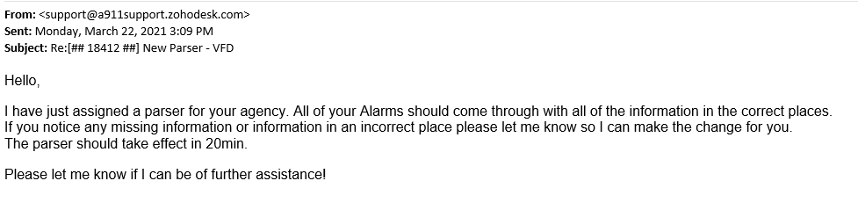

Navarro County Command
A special agency has been set up called Navarro County Command. This agency contains the chief and assistant chief of each VFD using Active911 in Navarro County. Sheriff Office dispatch cannot send alerts or pages to this group. Members of the group (chiefs and assistant chiefs) can create and send alerts to all the other chiefs and assistant chiefs. Each department is also individually identified as a GROUP. An alert can be sent to a GROUP (one department), several GROUPS (multiple individual departments), or EVERYONE. Chat can also be used to communicate with an individual department, several departments, or everyone.

Help
Additional help and documentation: You can find additional help and documentation online at:
https://active911.atlassian.net/wiki/spaces/AED/pages/29819026/How-to%2Barticles

